**WEEK 4**

**Interpret Kitchen Lay-out**

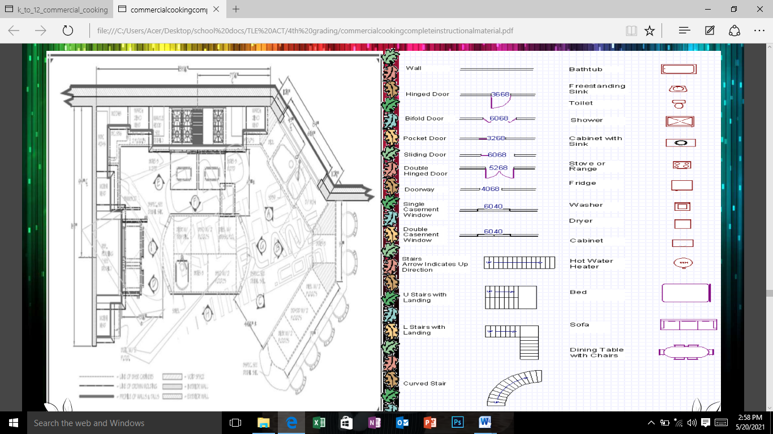

**Kitchen Floor Plan**

**Kitchen Symbols** 

**Understanding the Basic Kitchen Layout**

**Three Primary Kitchen Work Stations**

1. The Food Storage Station: Your refrigerator and pantry are the major items here.
2. The Preparation/ Cooking Station: Your range, oven, microwave, and smaller appliances are found in this area.
3. The Clean-up Station: Everyone’s least favorite activity. This area is home to the sink, waste disposal, and dishwasher.

**Work Station**

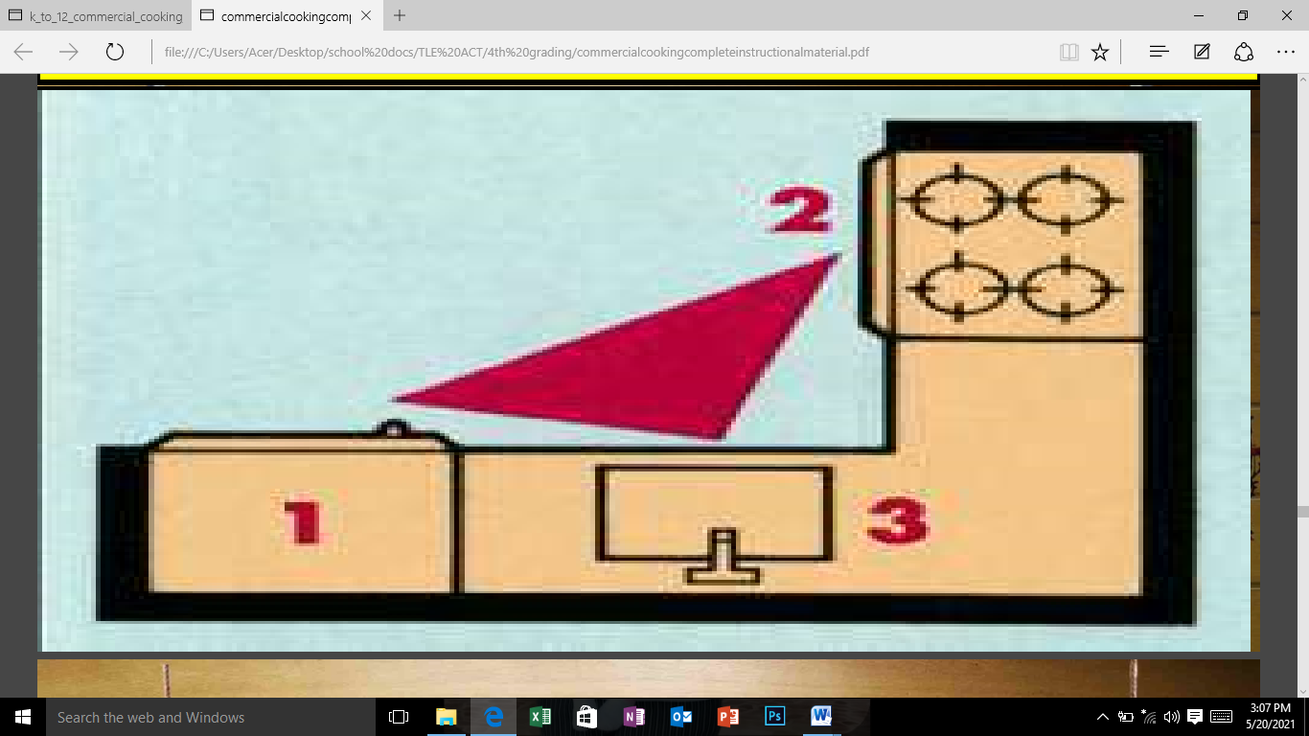

**Determining your Kitchen’s Layout**

**There are Five Primary Kitchen Layout Shapes:**

1. **THE U-SHAPED KITCHEN**

* Named for the “U” shape it resembles, this kitchen is popular in large and small homes alike.
* Perfect for families who use their kitchen a great deal.
* Provides plenty of counter space.
* Efficient work triangle
* Can convert one cabinet leg into a breakfast bar.

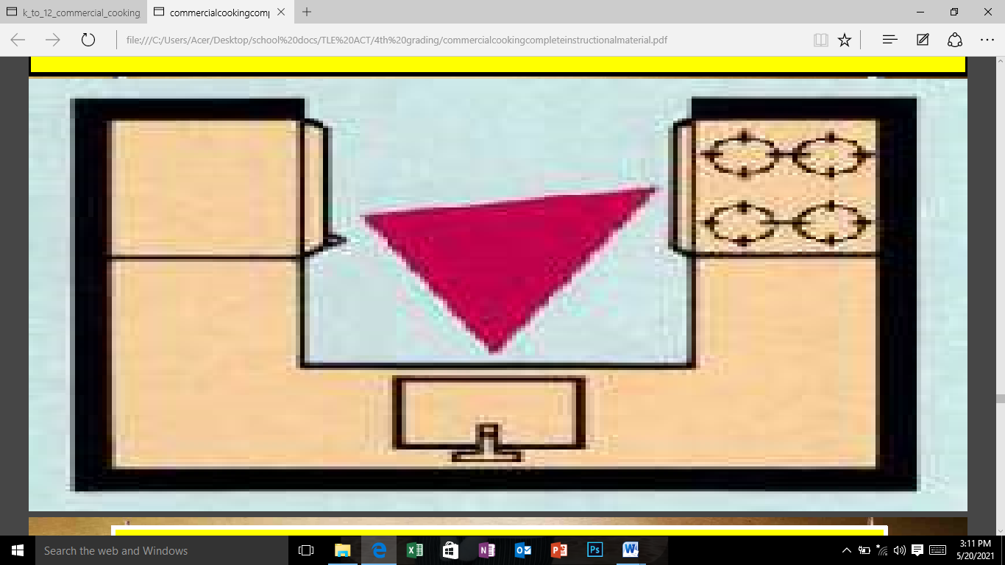

1. **THE L-SHAPED KITCHEN**

* This kitchen shape is one of the most flexible and most popular, providing a compact triangle.
* Very flexible layout design.
* Major appliances can be placed in a variety of areas.
* Work areas are close to each other.
* Can easily convert to a U-Shape with a cabinet leg addition.

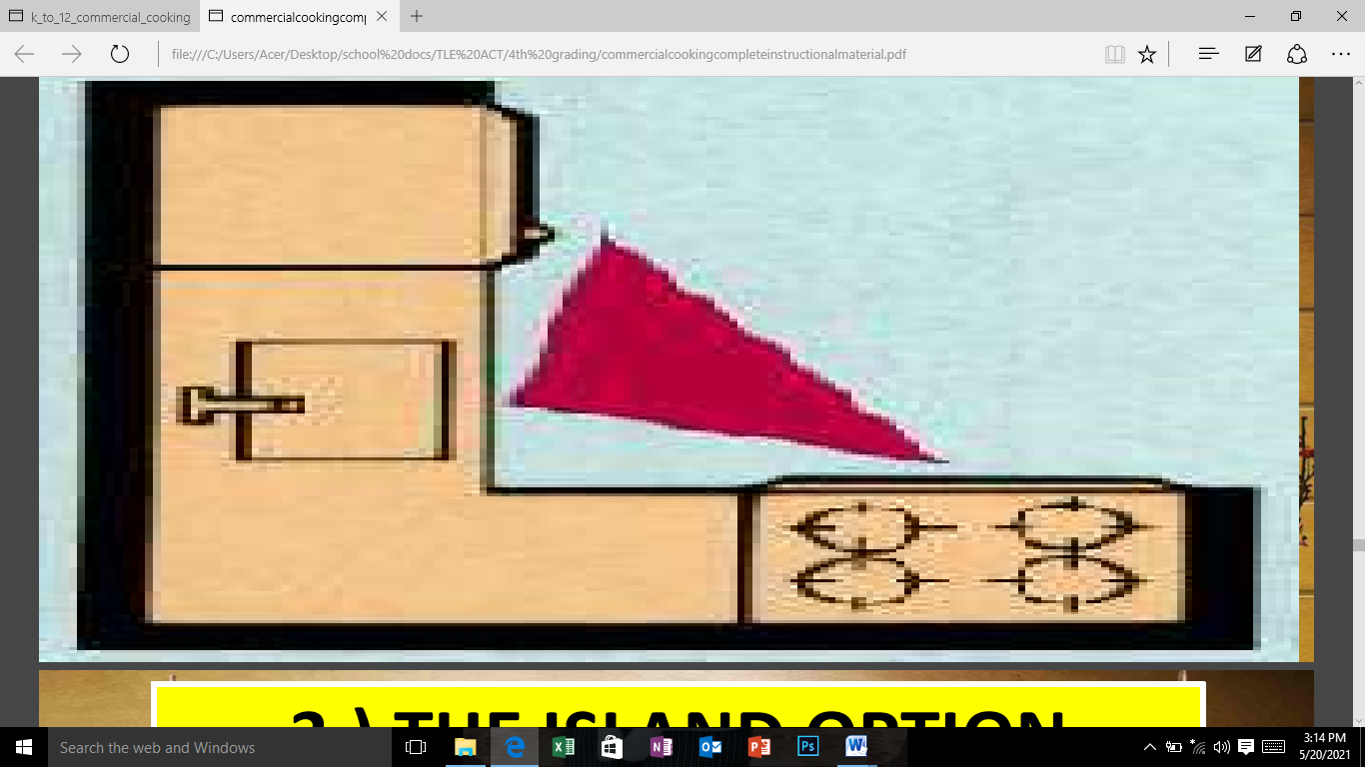

1. **THE ISLAND OPTION**

* Are extremely popular in homes today and are most often seen in L-Shaped kitchens.
* Islands can not only keep work areas traffic-free, but also create wealth of extra counter and storage space.
* It can be an indispensable food preparation station or act as a butcher block area.

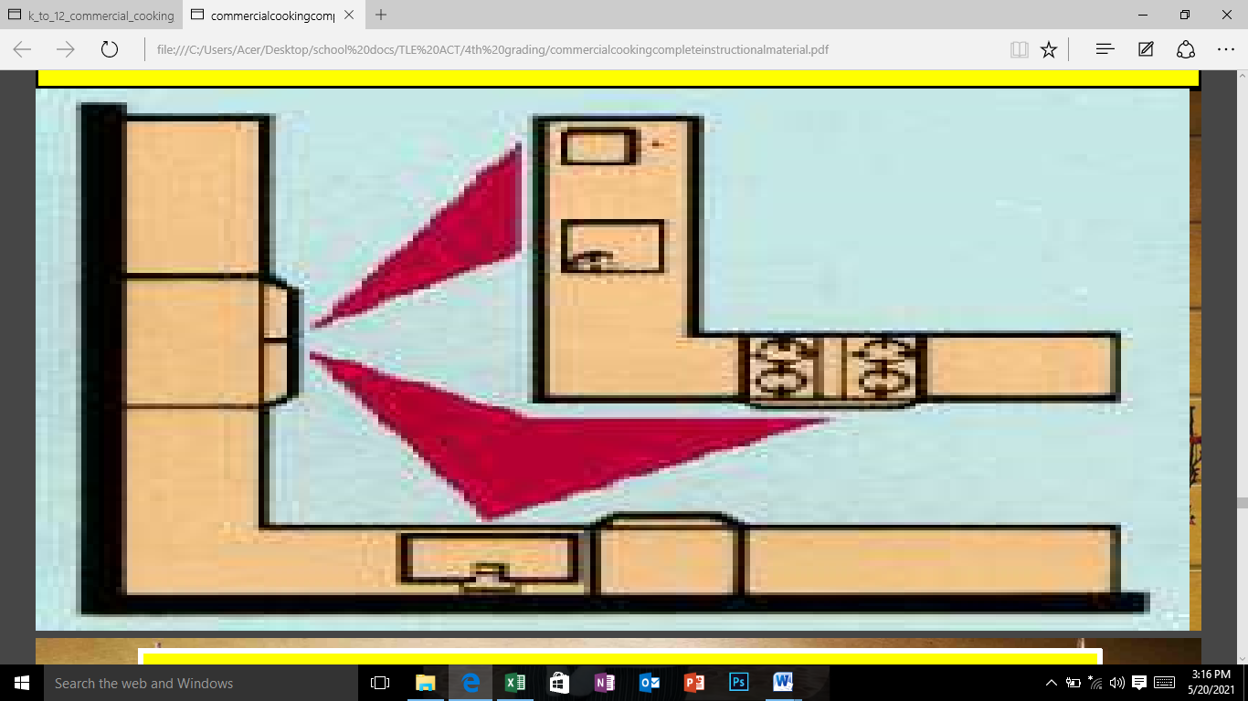

1. **THE G-SHAPED KITCHEN**

* Built very much like the UShaped with the addition of an elongated partial wall, the G-Shaped kitchen offers a great deal of space.
* Ideal for larger families needing extra storage space.
* Plenty of counter and cabinet space.
* Multiple cooks can function well in this layout.
* Can convert one cabinet leg into a breakfast bar or entertaining area.

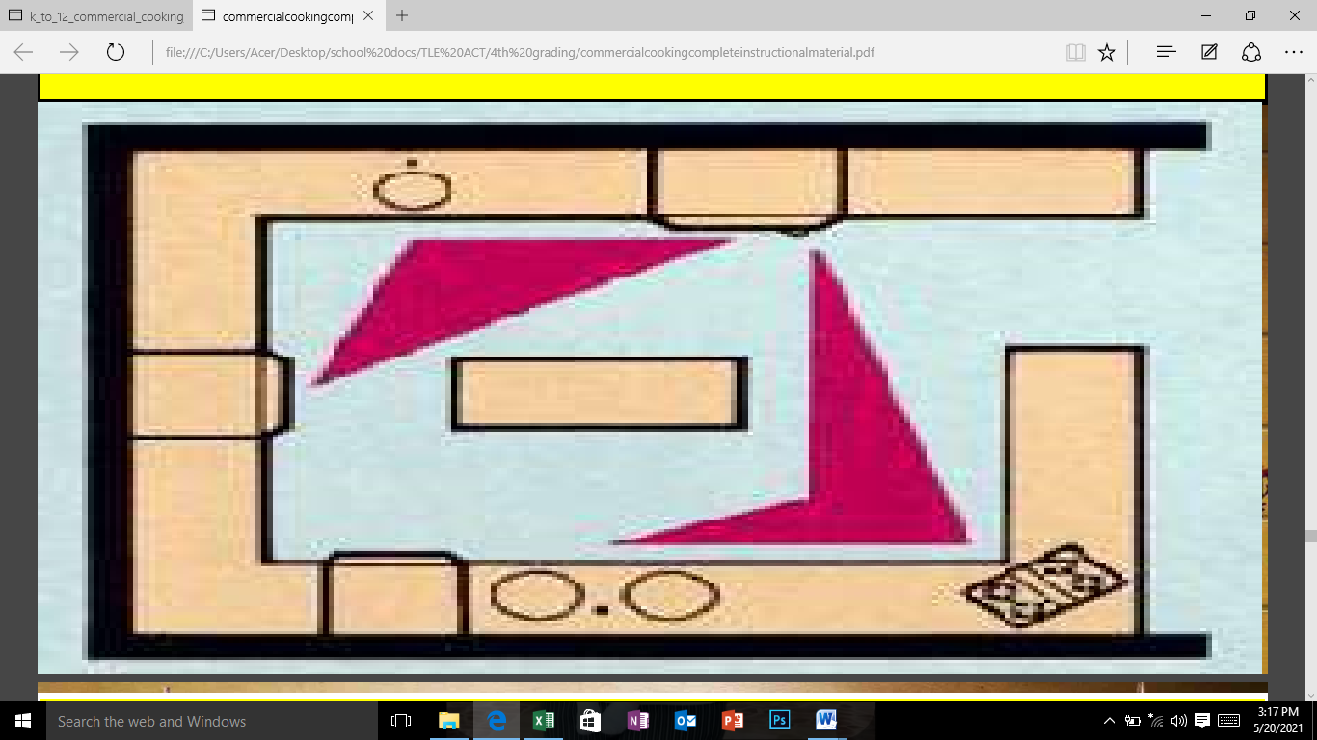

1. **THE CORRIDOR/ GALLERY KITCHEN**

* This style of kitchen makes the most out of a smaller space.
* Great for smaller kitchens
* Appliances are close to one another.
* Easy for one cook to maneuver.
* Can easily convert to a U Shaped by closing off one end.

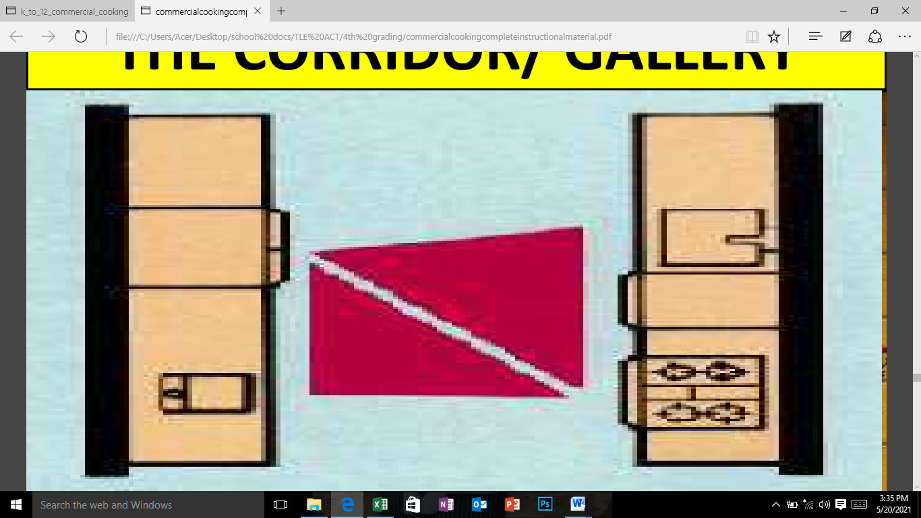

1. **THE SINGLE WALL/ PULLMAN KITCHEN**

* Designed for homes or apartments, the single wall kitchen offers a very open and airy feel.
* Ideal for apartments and smaller homes
* Works well with open designs found in many contemporary homes
* Small moveable table can provide eating space.
* Can be enhanced with the addition of an island.

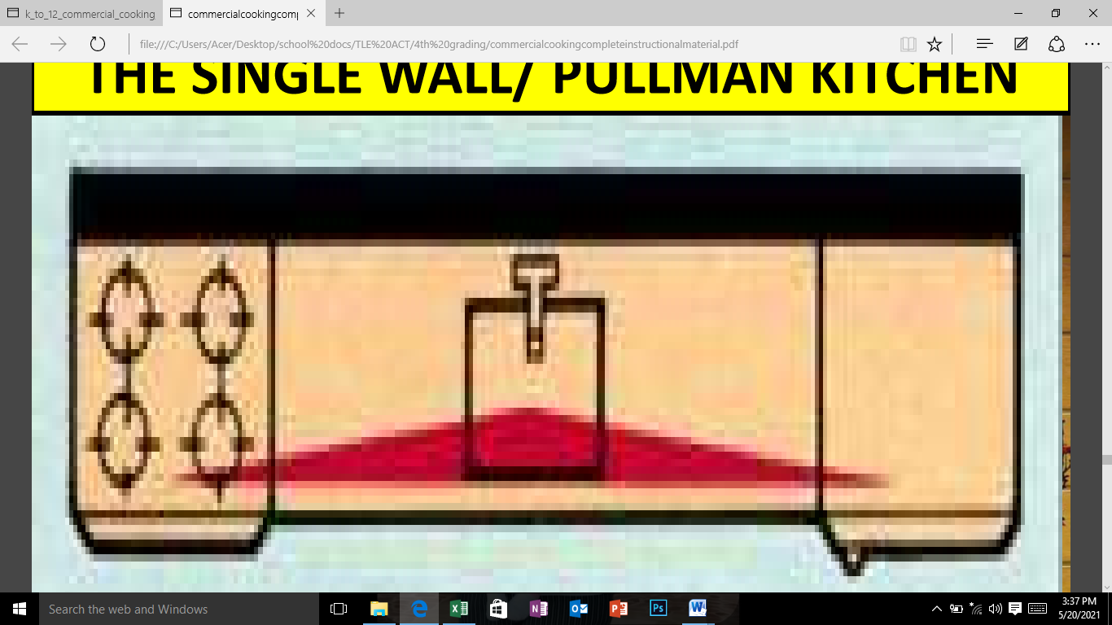

**Evaluation**

1. **Direction: Fill the blanks with word or group of words that will the statement complete.**

1. Work Station simply means a __________ __________ __________where a particular kind of food is produced .

2. Type of kitchen which is most suitable for large families is ___________.

3. Doing the job in the easiest, simplest and quickest way refer to ___________.

4. The term that means doing the job in the easiest, simplest and quickest way is ____________.

5. Type of kitchen which is the most popular and compact is ____________.

1. **Direction: Match column A with column B. Write the letter of the correct answer.**

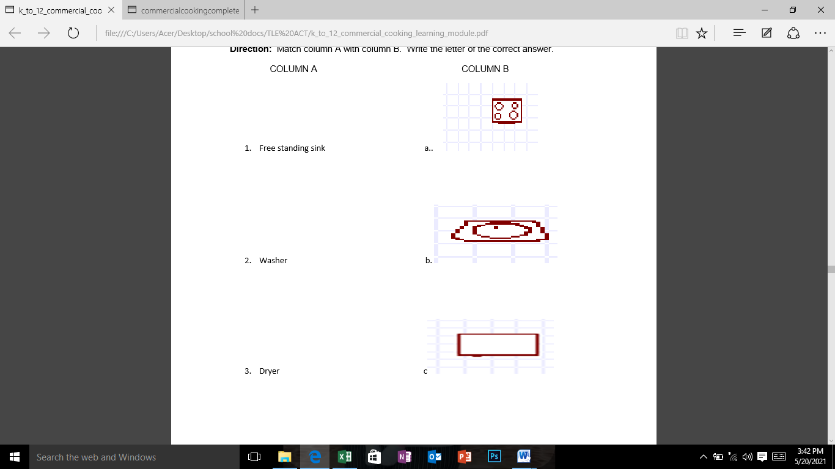COLUMN A COLUMN B

1. Free standing sink a..



2. Washer b.



3. Dryer c.

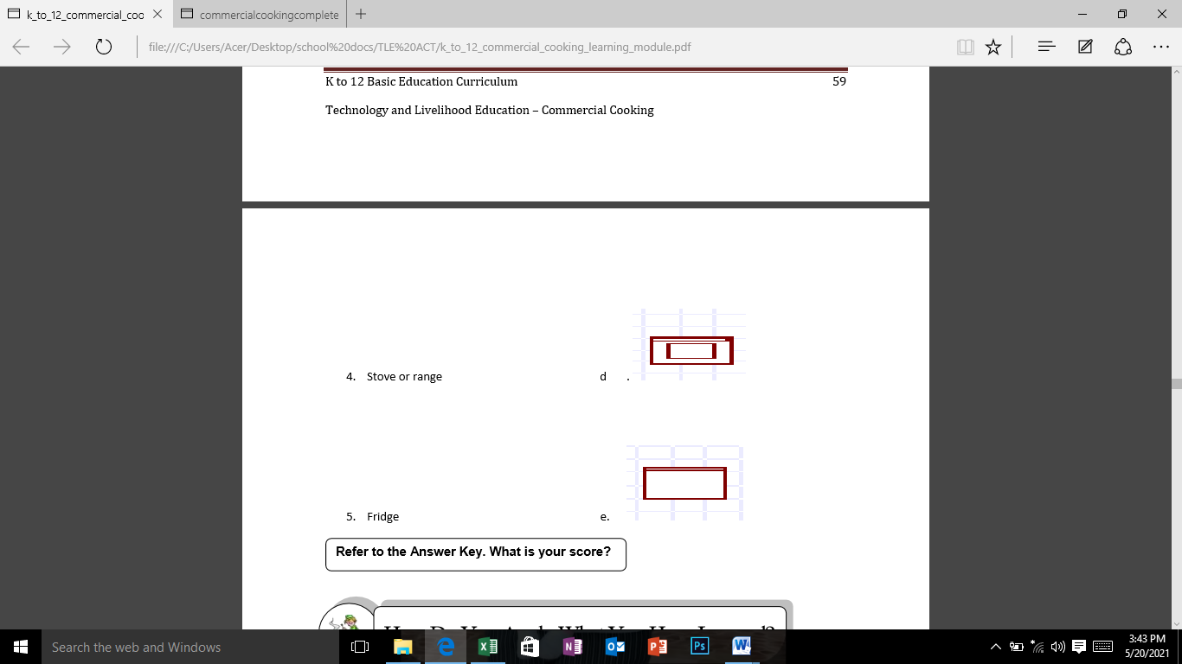

4. Stove or range d .

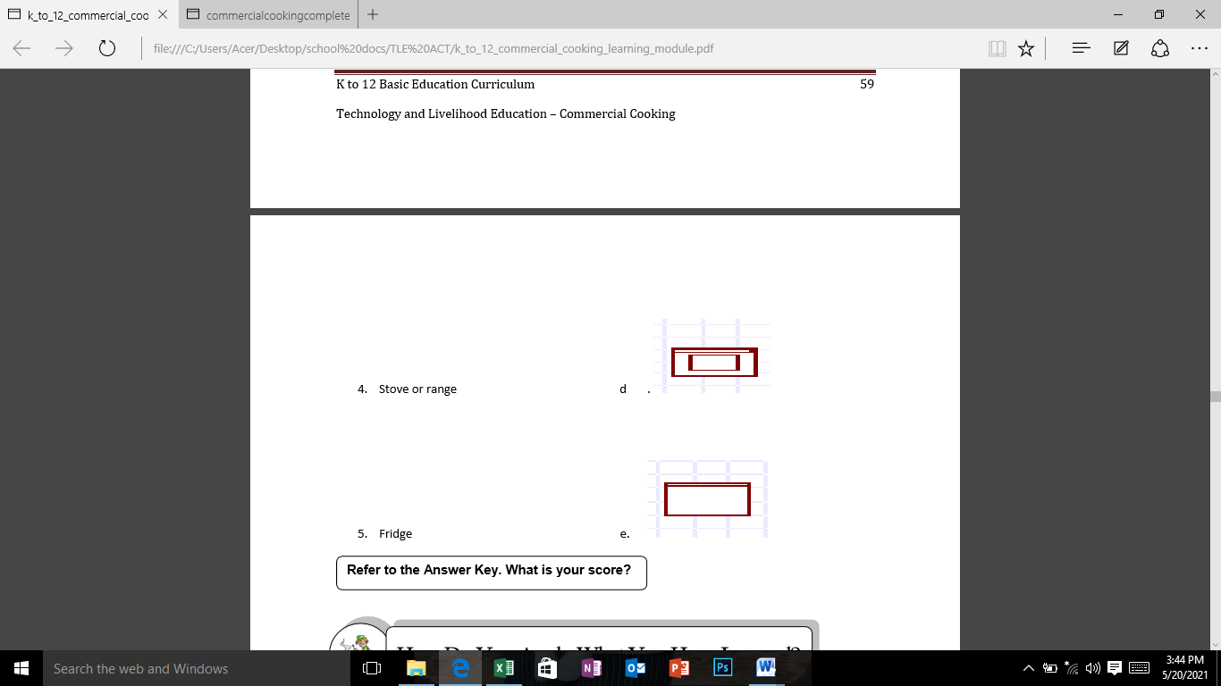5. Fridge e.

**Performance Task**

After having discussed the different kitchen floor plans and symbols , you are now ready to lay-out your own dream kitchen. Complete your sketch by placing the necessary symbols to show the different appliance, counters, areas and the direction of work flow.